**CO3202 Entrepreneurial Project– Interim Report**

**Balraj Singh**

*GearED – A Racing and Educational game*

**Contents**

**Summary of Proposal** 3

**Aims** 3

**Objectives** 3

**Requirement Analysis** 3

**Functional Requirements** 3

**Non – Functional Requirements** 4

**Target Audience** 4

**Competitor games** 5

**Unique Value Proposition** 6

**Customers** 6

**Revenue model** 6

**Software used** 6

**Design** 7

**Planning** 7

**Lean canvas** 7

**Bibliography** 8

# **Summary of Proposal**

The product I have decided to create for this project is a video game that will be created with the Unity game engine. This is a native gaming engine based on C++.**[2]** The game is a Racing game, a form of video game in which the player competes in a competitive racing competition. This can range from actual racing leagues to fantasy locales, so that the needs of the players are satisfied. The genre as a whole is extremely popular, with games like 'Forza Horizon 5' and 'Gran Turismo Sport' bringing millions of gamers, this shows the significance of the game and the potential gap in the market.**[1][3]**

# **Aims**

Building a project that is entertaining, interesting, and educational is my goal. To satisfy the needs of the customer, this game should be easily accessible and appropriate for all ages.  The game must also serve an educational purpose so that players can gain knowledge and understanding about cars and their mechanics while they are also enjoying playing the game.

# **Objectives**

The following objectives must be completed in order to accomplish these aims:

* Create game design document that will include all the game features, gameplay, and mechanics.
* Create the assets for the game (using blender, photoshop).
* Examine current games to identify market gaps.
* Make a fully functional game for players.
* Create a game using Unity.

# **Requirement Analysis**

This is the process of determining what users expect from a new or changed product. These characteristics, known as needs, must be quantitative, relevant, and comprehensive. This gives an idea as to what the players needs are and how they can, therefore, be achieved, which will closely examine the project's functional and non-functional needs.

# **Functional Requirements**

Functional requirements specify what a Game must be able to do, as well as its features and functions.

* (Must have) WASD keys for W-Up, A-Left, S-Down, D-Right change the car’s direction.
* (Must have) Different roads based on the maps.
* (Should have) will show the user's speed and the recent high score.
* (Must have) Let the player quit.
* (Must have) a primary menu where users can launch and exit the game.
* (Should have) a player can inspect the vehicle.
* (Could have) Players will have the choice to alter the colour of their vehicle and select the vehicle of their choice.
* (Must have) Players can inspect the parts of the car and read about it.

* (Could have) Background music.
* (Should have) Sound effects.

# **Non – Functional Requirements**

Non-functional requirements list a system's basic aspects.

* **Usability**

1. GearED should be simple to play, as it’s made for all ages.
2. The game should run smooth, otherwise the players will not like it.

* **Reliability**

1. In 90% of its duration, the GearED should be crash safe.

* **Performance**

1. The GearED's loading time must be under 10 seconds. Other reaction times have to be less than two seconds.

* **Compatibility**

1. It will be able to run on windows 7 and new versions. E.g.

Processor - A CPU that supports SSE2

RAM - 512 MB

Graphics card – N/A

Storage – 500 mb

* **Security**

1. No data will be stored onto GearED, other than the basic information like name and control key binds.

# **Target Audience**

The target audience for GearED will consist of children from the age of five all the way up to the youth age of 30 years old, or someone who is interested in the automobile industry and wants to learn about specific cars. After doing a quanitative survery online, I will analyse the results and display them using a pie chart, as you can see below, this demonstrates that this specific age range of players enjoy interacting with racing games.**[4]**Chart, pie chart

# **Competitor games**

After analysing relevant research, I discovered other racing games, which are mostly played on gaming consoles such as PlayStation and Xbox. **[5][6]** This is due to the fact that they are made to be simple to set up and maintain. It is easy to start playing on a console right away after you take it out of the box. To begin having fun, no technical knowledge or build times are required, which negates any issues of the game being overwhelming, so enjoyment is not lost.

One of the games that caught my eyes was Forza Horizon 5, **[5]** which is a racing video game and was created by Playground Games and released by Xbox Game Studios in the year 2021. It is the twelfth major Forza series instalment and the fifth Forza Horizon game. A fictitious version of Mexico serves as the setting for the game. On steam this Forza Horizon 5 has over 80,000 positive reviews and has 10 million downloads. However, I can also take inspiration from Forza Horizon 5 for example add the mini-map and speedometer, the mini-map will show the player where they are going, the speedometer will show what speed the car is travelling at, making the experience more realistic and thrilling.

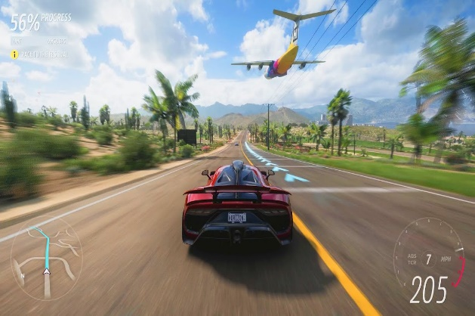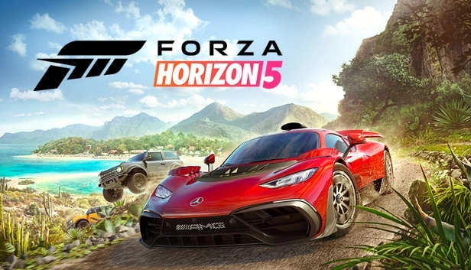Figures above shows the images from the actual game and the front cover of the game, which is very high quality and that is something I want to replicate in my game, because that will attract a wider audience base due to the aesthetics.

The next competitor that I found during my research is 'Gran Turismo Sport', which is also a racing game which was created by Kazunori Yamauchi.**[7]** Gran Turismo was created by Polyphony Digital and released for the PlayStation video game console by Sony Computer Entertainment in 1997. As of April 30, 2008, it had shipped 10.85 million copies worldwide and had an average rating of 95% from Game Rankings. It was well-liked by both the general public and the media.

In the game there are numerous race circuits, where the player controls a car to battle against AI drivers. Arcade Mode and Simulation Mode are the game's two modes of operation. In Arcade Mode, the player can select an automobile and racetrack from the available choices before starting a race against AI players. By winning races on various tracks and in various vehicle classes, the player can access additional vehicles to use and additional racetracks to race on.**[6][7]**

# **Unique Value Proposition**

I will work hard to create a top-notch, excellent game that will benefit players who appreciate racing and desire to learn more about vehicles by providing them with a fun and exciting racing game, which includes relevant, insightful information about cars.

My unique proposition is to develop a racing game that is gratifying, entertaining, and educational. I also want this game to be accessible and, therefore, played on a platform that is distinct from those used by most other games in the category. This game stands out from other racing games because you will be able to customise and personalise your own car, including its colour, exterior design, wheels, and other features. Another unique feature of GearED will be if you hover over any part of the car with your cursor it will supply you with more information about the specific part of the car.

# **Customers**

The customers of the game I’m developing (GearED) will be different type of players, ranging from ages 10 to 30 years old, in order to find out if the customers will like the game. I will be having different people to trial and test out the game, and see what the reviews are like, to identify what needs to be improved. However, I will also be giving out the early access to some twitch streamers to see what their first opinions/impressions are about the game and that also, consequently, means this will indirectly promote the game to a larger array of audience around the world. A lot of youngsters in this modern age watch Twitch streamers and are easily influenced so if the Twitch streamers they watch are playing the game the viewers will want to trial them out as well.

# **Revenue model**

GearED will make Revenue through Steam.**[8]** However, it can be difficult to get into such a large market, but Steam has supported many independent creators and has the power to make or destroy a game. As there are fees associated with getting my game listed on Steam, as well as a number of rules I must follow, I will need to build a sizable player community, for example if my game is played by a Twitch streamer and it starts to become widely recommended. That is why promoting the game through Twitch streamers will be a beneficial option because it can widen the number of players using the game. I will also sell packs and limited time car deals for the players to buy. For example, players can buy a pack which will contain different types of cars that they can unlock and ultimately, start playing with. Players will also have an option to buy coins and gems, with which they can unlock specific car modifications, for example, making the car faster or customising the colour of the car etc.

# **Software used**

I'll be using a variety of software's, including Unity. Unity is renowned for its superior graphics and cutting-edge visual effects. Making aesthetically pleasing games is made easier by the game engine's highly flexible rendering technology and a wide range of user-friendly tools. Unity also has an asset store, which will help massively with 3D structures, textures and so on. I will also be using Adobe Photoshop to make the wallpaper for the game **[11]**. Blender will also be one of my most used softwares for the 3D modelling, it offers excellent modelling, rigging, rendering, animation, motion tracking, and some options for creating games and videos. **[9]**. To attract the players, I will be making a trailer using Sony Vegas pro-15, since it allows me to edit video clips. Sony Vegas Pro is a very helpful tool that we frequently use in my project. The programme is distinguished by the fact that it can make or change films in extremely high resolution up to 4k and 2k. **[10],** most of these software’s I already own, or they are free. 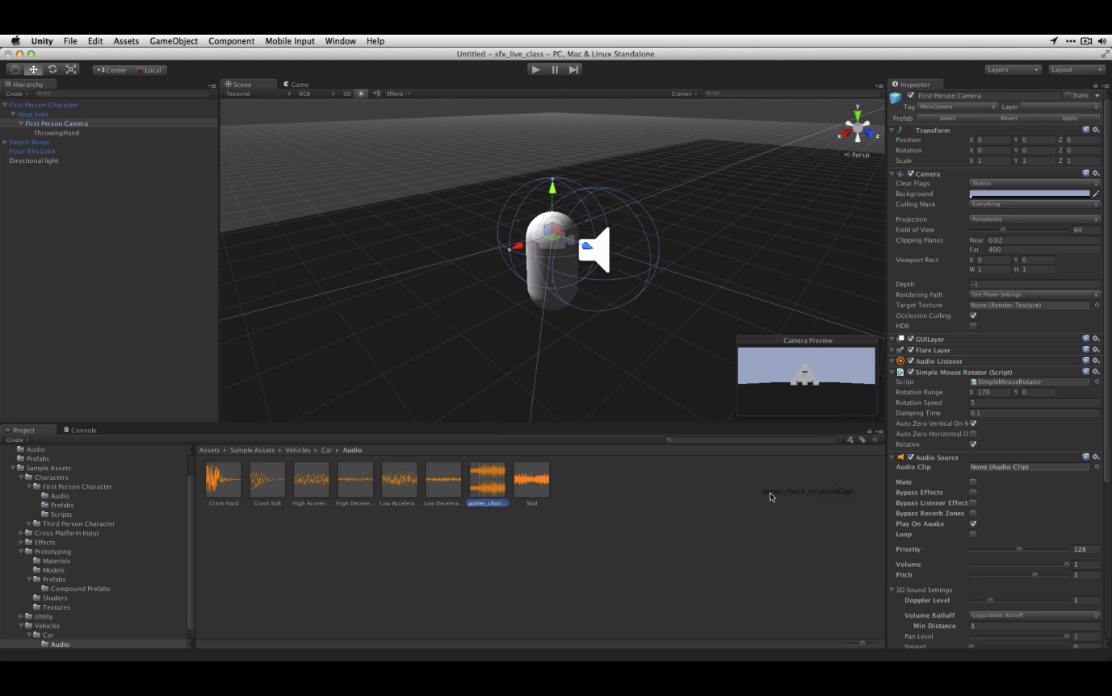

# **Design**

The visuals in GearED will be appearing like the picture I have included below, in order to collate the necessary information about the specific car you click on the “+” sign, and the information will automatically pop up. That will be a beneficial quality for players, who are trying to gain more knowledge about the cars while they are playing the game.

# **Planning**

Its important to have a good planning because without good planning, it is almost impossible to guarantee that a business distributes and utilises resources in the most sensible and economical manner. Specifying the project's aims and objectives is a crucial step in the planning process. Team leaders find it simpler to transform project objectives into quantitative measurements of success when they are well-defined and explicit.

# **Lean canvas**

I also used a business modelling tool called the Lean Canvas which was developed to assist in breaking down a company idea into its most important and dangerous assumptions. The Lean Canvas, which is heavily influenced by the lean startup process, serves as a tactical roadmap to help entrepreneurs move from ideation to creating a successful startup. Which will be good for GearED because it gives me a knowledge of the GearED's competitive advantages and a greater understanding of how the GeardED will operate.

# **Bibliography**

# **[1]** *nichegamer.com. (2021). Forza Horizon 5 Downloads Top 10 Million,*

*Biggest Launch in Xbox History - Niche Gamer. [online] Available at:* [*https://nichegamer.com/forza-horizon-5-downloads-top-10-*](https://nichegamer.com/forza-horizon-5-downloads-top-10-) *million/#:~:text=Forza%20Horizon%205%20Downloads%20Top%2010%20Milli on%2C%20Biggest%20Launch%20in%20Xbox%20History [Accessed 6 Nov. 2022].*

**[2]** *Unity Technologies (2019). Unity - Unity. [online] Unity. Available at: https://unity.com/.*

**[3]** *Gran Turismo Sport Review - IGN. (2017). IGN. [online] 17 Oct. Available at: https://www.ign.com/articles/2017/10/17/gran-turismo-sport-review [Accessed 6 Nov. 2022].*

***[4]*** *Newzoo. (n.d.). Racing Player Consumer Insights: Demographics, Gaming Preferences, Behavior, Brand Attitudes, and More. [online] Available at:* [*https://newzoo.com/insights/articles/racing-player-consumer-insights-demographics-gaming-preferences-behavior-brand-attitudes-and-more*](https://newzoo.com/insights/articles/racing-player-consumer-insights-demographics-gaming-preferences-behavior-brand-attitudes-and-more)*.*

***[5]*** *store.steampowered.com. (n.d.). Forza Horizon 5 on Steam. [online] Available at: https://store.steampowered.com/app/1551360/Forza_Horizon_5/ [Accessed 7 Nov. 2022].*

***[6]*** *gran-turismo.com. (n.d.). products. [online] Available at: https://www.gran-turismo.com/us/ [Accessed 7 Nov. 2022].*

***[7]*** *“GAME - History of Gran Turismo Series.” Www.game.co.uk, www.game.co.uk/webapp/wcs/stores/servlet/ArticleView?articleId=89670&storeId=10151. Accessed 23 Nov. 2022.*

***[8]*** *“Welcome to Steam.” Steampowered.com, 2019, store.steampowered.com/.*

***[9]*** *Blender Foundation. “Blender.org - Home of the Blender Project - Free and Open 3D Creation Software.” Blender.org, 2019,* [*www.blender.org/*](http://www.blender.org/)*.*

***[10]*** *“VEGAS Pro: Video & Audio for Professionals.” Www.vegascreativesoftware.com,* [*www.vegascreativesoftware.com/gb/vegas-pro/*](http://www.vegascreativesoftware.com/gb/vegas-pro/)*.*

***[11]*** *Adobe. “Buy Adobe Photoshop | Best Photo, Image, and Design Editing Software.” Www.adobe.com, www.adobe.com/uk/products/photoshop.html.*

***‌***

*‌*

*‌*

*‌*

‌